HRAC Meeting Minutes
Monday, January 22, 20235
Gatehouse Administration Conference Room 5055
5:30 p.m. to 7:30 p.m.

HRAC Charge: HRAC will make recommendations to improve practices used by FCPS leadership at school & district levels from the lens of professional/ business acumen, data integrity, diversity & inclusion to improve FCPS’s national & international competitive standing as it relates to compensation.

HRAC Norms: Punctual *Prepared* Participatory *Positive* Productive* Present* Speak up

Time | Topic | Facilitator
5:30 p.m. | Welcome  - Call to Order  - New School Board Liaison Introduction  - December Meeting Notes (Vote) | HRAC Co-Chair Laverne Henson
5:45 p.m.-7:10 p.m. | - HR Compensation Presentation & Discussion | HR Director of Employee Services & Operations  Maike Dunlap
7:30p.m. | Call for Motion to Adjourn | HRAC Co-Chair Leonard Bumbaca

Committee Members |  | Represents
Dr. Sherry Agnew Scott |  | Asst. Superintendent for Human Resources
Mr. llryong Moon |  | School Board Liaison
Amira Bouhsane |  | Student Rep
Leonard Bumbaca |  | Mason District
Mimie Dash |  | Providence District
Anita Guyther-Branch |  | At Large Representative- Mr. Moon
Laverne Henson |  | At Large Representative-Kyle Daniel
Chris Lewis |  | School Board Asst to Mr. Moon
Janet O’Lare |  | At Large Representative -Rachna Sizemore Heizer
Dionne McGlothin |  | Sully District
Haile Russom |  | Franconia District
Angela Thompson |  | Mount Vernon District
 | Visitors | Represents
 | JeanMarie Nagle | Fairfax Federation of Teachers
 | Sandra Hardeman | HR Executive Director
 | Krista Simkins | Director, Office of Talent Acquisition
 | Lydia Martinez | Director, Office of Labor Relations
 | Franklin Jones | Director, Office of Employee Relations
 | Maike Dunlap | Director, Office of Employee Services & Operations

Meeting called to order at 5:40 pm by Laverne Henson, HRAC Co-Chair

December 4, 2023 meeting minutes were approved pending administrative name corrections

Introductions:
A brief introduction was given by Mr. Leonard Bumbaca introducing Mr. IIryong Moon as the new School Board Liaison. Mr. Moon stress his role is to ensure HRAC concerns are filter through the schoolboard. He concurs with the charge as read.

Dr. Agnew Scott introduce her priorities for the evening discussion as it relates to salary adjustments, cycle reviews, recruitment/retention and quality reporting as a major component of competitive standing and compensation.

Presentation by Maike Dunlap, Director, Office of Employee Services and Operations (ESO)
Ms. Dunlap presented an introduction to the Office of Employee Services and Operations (within the Human Resources Department) and an introduction to the team function(s) for Classification and Compensation. She explained that their compensation philosophy (goal) is to ensure our compensation, across each position, be within the range of 95% to 105% of the market average for the position. The team also handles job description updates, job classifications, cyclical reviews, and benchmarking and salary studies. They do not manage Hourly Bands or salary increases owned by Finance or the entire, overall compensation packages.

In terms of how we’re meeting our goal for our overall Unified Scale, the percentage of positions meeting the target (i.e. b/w 95% and 105% of mkt avg) is 82% for entry level staff, 71% for mid-career staff, and 55% for late-career (experienced) staff. This begs the question of how are likely to be losing staff as they gain tenure in the system due to a lack of competitiveness in compensation. This is something we should explore in greater detail.

Ms. Dunlap also shared a breakdown of our competitiveness in teacher compensation relative to our 9 neighboring school districts where we ranked:

Teacher Compensation | Ranking*
BA, Step 1 | 6 out of 10
Masters, Step 1 | 9 out of 10
Masters, Mid-career | 5 out of 10
Maximum | 9 out of 10
* WABE (Washington Area Boards of Education) competitive benchmark comparison

Also, in the presentation Ms. Dunlap shared with the Committee the process of how cyclical reviews are handled, the stakeholders, and timelines for completing the multiple work phases starting with the process initiation and culminating with the implementation and closure of the review (see below).

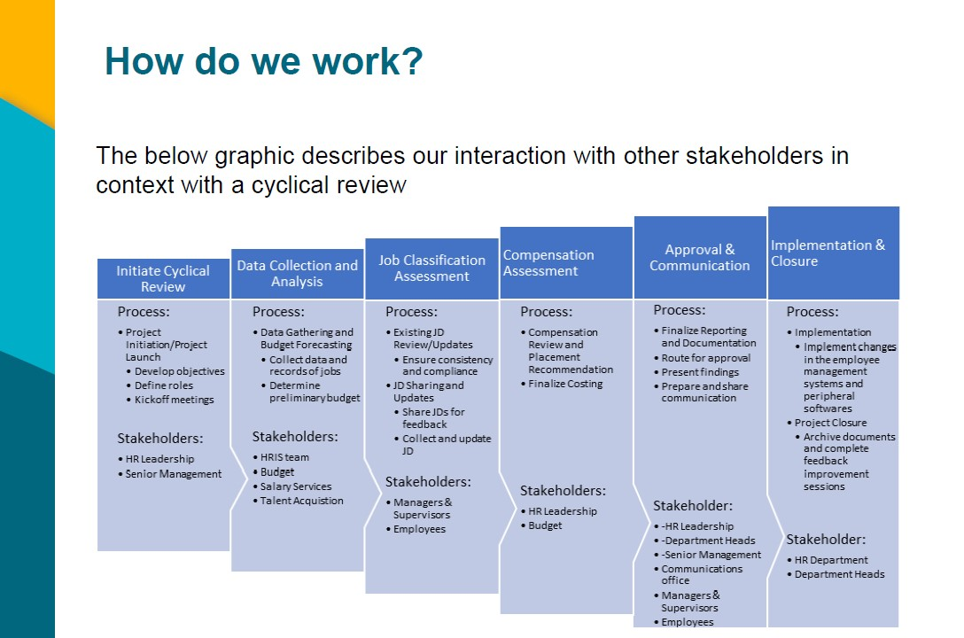

Ms. Dunlap also discussed the complex process of reviewing and revising job descriptions which led to a discussion between committee members about staff who are tasked with actions that are not in their job descriptions and a question was asked and answered relating to where those concerns should be forwarded. Also discussed was a noted discrepancy between jobs posted through HR directly versus posted directly via Uconnect and that the latter can sometimes create inconsistencies in the job description and posting information that the Team is trying to standardize. Dr. Scott committed to look further into that concern.

Mr. Moon inquired as to whether our salary compensation comparisons included national and international comparisons and referenced the per capita income, as an example, in Korea versus United States and the relative salary of teachers in the two countries (relative to the median household income) to demonstrate the level of respect given to teachers in Korea over how teachers are seen within the United States. No next steps were identified but the information was noted for consideration.

Employee Bill of Rights, Co-chair Leonard Bumbaca
Mr. Bumbaca introduced conversation around an employee Bill of Rights and whether this made sense to pursue so that employees better understand rights and responsibilities and how to handle situations and concerns when they arise regarding job duties. The discussion ended with a conversation about developing an employee handbook that would standardize the rights and responsibilities of employees -- similar to how we already develop a “Student Rights & Responsibilities (SR&R)” handbook -- and the next steps were that the Committee investigate how the SR&R was developed and determine whether the Committee had support from the Board for such an action. Mr. Moon indicated that he didn’t want to heavy handedly steer the conversation one way or another and suggested that the Committee decide whether to present the Bill of Rights to the Board during its final presentation. There was conversation about whether to consult with Division Counsel on the creation of the Bill of Rights and the Committee agreed to take that under consideration but no next steps were identified.

Request for School Board:
Schedule a mid-year review with school board members.

Committee Action Items
(1) Cross walk policy that aligns to the Bill of Rights– HR, Mr. Franklin Jones (OER)

(2 Connect with Budget for the cycle review as you work through budget group. - HR, Maike Dunlap, (ESO)

(3) Inquiry on outsourcing Cycle Review 1, Year FY25 and 2, Year FY26 for 950 Jobs. – HR, Maike Dunlap, (ESO)

(4). Obtain Market Competitiveness, Budget Constraints, Job Classification Accuracy, Staffing Support and Policy/Regulation Limitations. – HRAC Committees

Next meeting: February, 5:30-7:30p.m. Gatehouse Administration Center Room -5055
- Committee Assignments

Wrap Up/Call to Motion to Adjourn: 7:30 p.m.

